EXP : 4
Date : 14-07-2026
DML Commands – UPDATE, DELETE
AIM:
To perform Data Manipulation Language (DML) commands such as UPDATE and DELETE in the table.
PROCEDURE:
Step 1: Select the database containing the patients table.
Step 2: Update the Insurance provider of a selected patient using the UPDATE statement.
Step 3: Verify the updated record using the SELECT statement.
Step 4: Delete a selected patient record using the DELETE statement.
Step 5: Display the remaining records to verify the deletion.
Query 1 :
UPDATE patients SET Insurance = 'Apollo Munich' WHERE P_id = 204;
Output 1 :
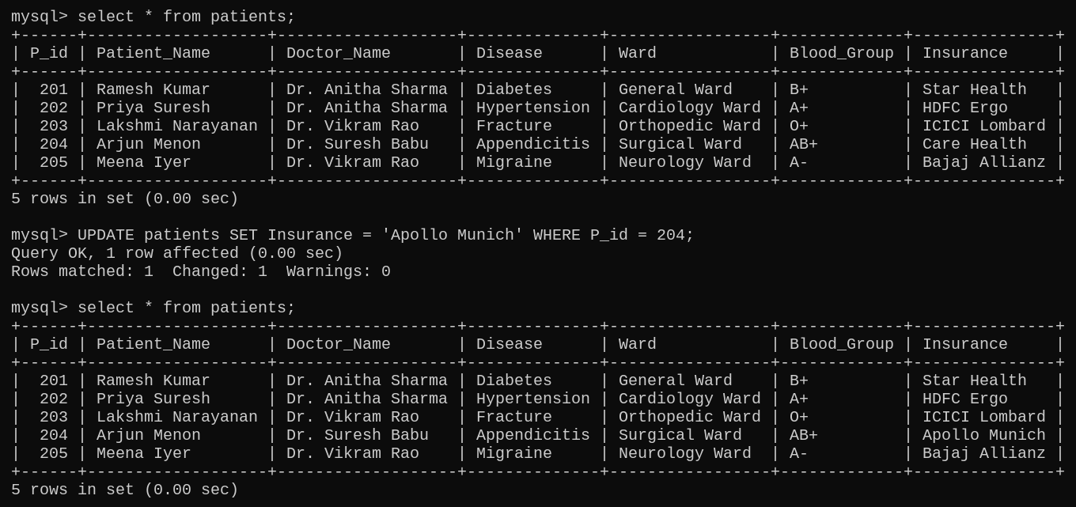
Query 2 :
DELETE FROM patients WHERE P_id = 205;
Output 2 :
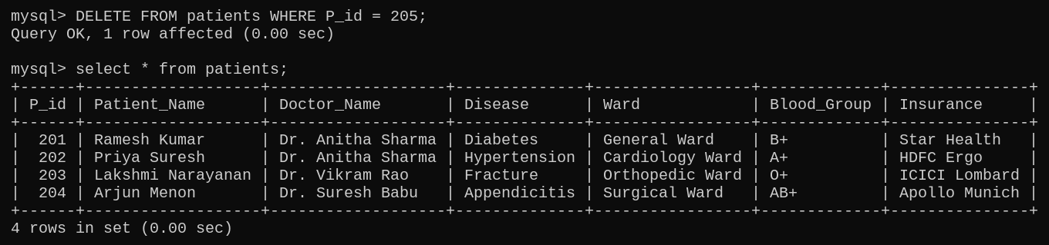
Result : Thus, the Data Manipulation Language (DML) commands UPDATE and DELETE were executed successfully. The patient record was updated and deleted successfully from the patients table.

